**Computer Networking (PRACTICALS) – FALL 2012**

**EXPERIMENT 3**

|  |  |
| --- | --- |
| **DATE: Friday Oct 5, 2012** | **Students Names: Capt Sumeer Riaz** |
| **Marks Obtained: _____** | **COURSE: BESE 16 B** |
| **Deadline: 1400 hrs 5th Oct 2012** | **Instructor: Engr. Kabeer Ahmad** |

**Comparison between Switch and Hub time for Packets transmission**

|  |  |  |
| --- | --- | --- |
| **Number of Packets** | **Average Time for HUB** | **Avrg Time for Switch** |
| **10** | **5ms** | **6ms** |
| **15** | **6ms** | **7ms** |
| **20** | **5ms** | **7ms** |
| **25** | **6ms** | **7ms** |
| **30** | **6ms** | **8ms** |

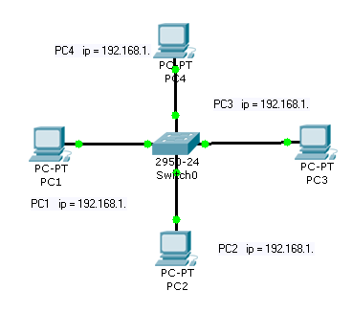 **For Hub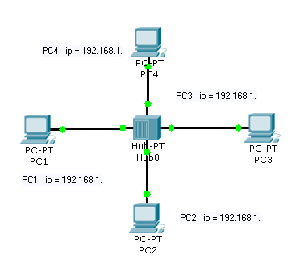: For Switch:**

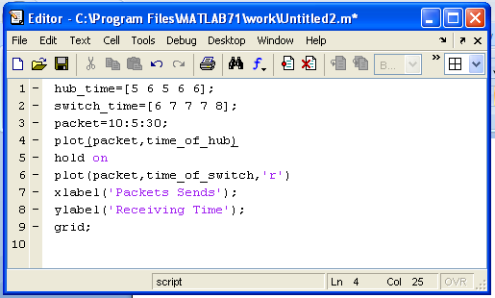**Code:**

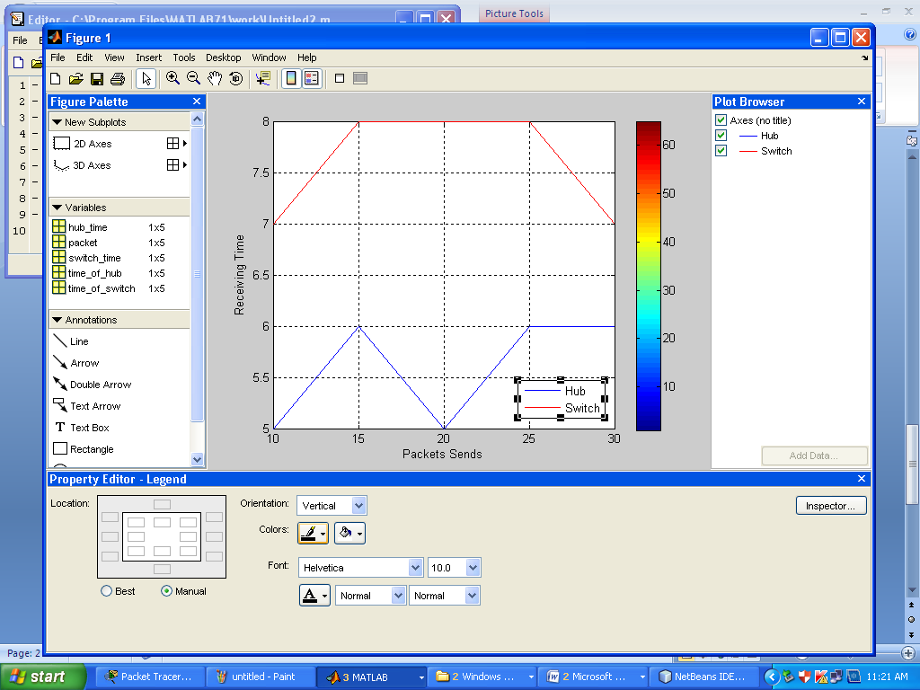**Graph:**